36.57: The phase shift for adjacent slits is 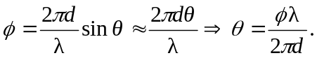
So, with the principal maxima at phase shift values of 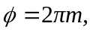and 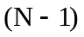 minima between the maxima, the phase shift between the minima adjacent to the maximum, and the maximum itself, must be 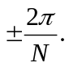
Therefore total phase shifts of these minima are 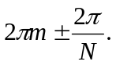
Hence the angle at which they are found, and the angular width, will be:

